VINH LONG UNIVERSITY OF TECHNOLOGY EDUCATION

**PRACTICE CENTER**

TEST PROJECT

PRACTICAL SKILLS

MODULE 1: WEB DESIGN

**Exam Paper Code: WD01**

|  |  |
| --- | --- |
| **SCHOOL LEADERSHIP** | **CHIEF SUBCOMMITTEE ON EXAM DEVELOPMENT** |

**Vinh Long, month 07/2020**

**GUIDE CONTESTANTS**

**Time:**

* Preparation Time: 05 minutes
* Time Duration: 150 minutes
* Break Time: 10 minutes

**Scores:**

|  |  |  |
| --- | --- | --- |
| **Exam content** | | **Marks** |
| 1 | Programming with HTML/CSS | 30 |
| 2 | Programming with JavaScript | 30 |
| 3 | Use the MySQL | 10 |
| 4 | Programming with PHP | 30 |
| **Total Marks** | | **100** |

**Candidates are required to note:**

* Ensure safety standards of health and computer
* Do the test independently without discussing while doing the test
* Comply with regulations of exam room and proctor’s instructions
* Fill the information in the form
* Complete all requirements in the content of the exam
* Do not use documents, the Internet and other communication devices during the assignment
* If the exam does not have special requirement for the file name and storage location, contestants save all exam file name in the folder as following format**: D:\WorkSkills\Web Design**

***<Student’s Name>_<*** ***Student code >[.<*** ***extension >]***

**CONTENT OF THE TEST**

**Question 1:**

**Programming with** **HTML/CSS:**

Use HTML/CSS code to design the following page:

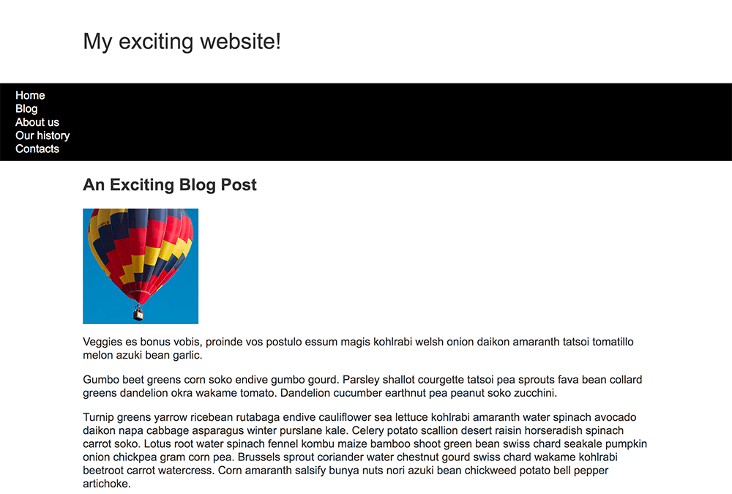

# **DESCRIPTION OF PROJECT AND TASKS**

* + Make heading “My exciting website!” is black, bolders and make them use Arial font or any serif font on the system.
  + The navigation bar will have a black background color.
  + The navigation items should have link is white and its font-size is 120%.
  + Make subheading “An Exciting Blog Post” is black and bolders.
  + The ballons picture name is ballon.jpg. It also links to <http://www.vlute.edu.vn/>.
  + The picture should have no borders and be 250 pixels wide.
  + The text section under the image must be way to 20px with the image.
  + The navigation bar should scroll with the content and then become stuck at the top of the viewport when it reaches it.
  + The definition terms are bolded.
  + Notice that there are two distinct sections on the page.
  + The content inside each section should be 20 pixels away from all edges.

**Question 2:**

**Programming with** **JavaScript:**

Write the necessary JavaScript code **createtable.js** for the functionality of the following page:

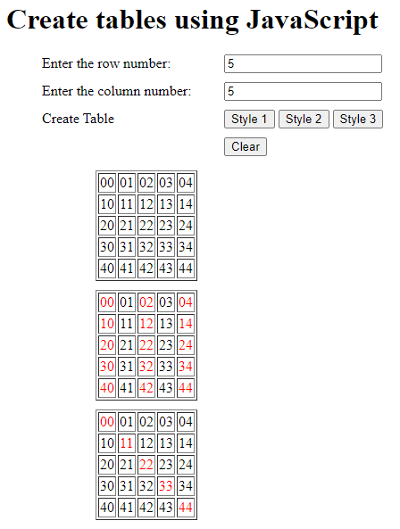

**DESCRIPTION OF PROJECT AND TASKS**

* This page allows users to create tables based on the number of rows and columns of different styles.
* The input box for the column number has id "numCol".
* The input box for the row number has id "numRow".
* The "Style1" button has id "style1".
* The "Style2" button has id "style2".
* The "Style3" button has id "style3".
* The "Clear" button has id "clear".
* When the user clicks on "Style1", the page will create a table with the number of columns and rows given in the input box on the page.
* When the user clicks on "Style2", the page will create a table with the number of columns and rows given in the input box on the page. Red highlight the contents of cells whose columns are odd numbers.
* When the user clicks on "Style3", the page will create a table with the number of columns and rows given in the input box on the page. Red highlight the contents of cells diagonally from left to right.
* Clicking the "Clear" button will delete the contents of the column and row data box.

**Question 3:**

**Use the MySQL create database Mannerings:**

***The database schema:***

|  |  |  |  |  |  |  |
| --- | --- | --- | --- | --- | --- | --- |
| **Houses** | | | | | | |
| REFNO | TOWN | TYPE | BEDROOMS | PRICE | HEATING | GARAGE |
| 13678 | Croydon | Detached | 4 | 250,000 | Yes | Double |
| 13679 | Croydon | Semi-Detached | 3 | 165,000 | No | Single |
| 13700 | Redhill | Flat | 2 | 110,000 | Yes | None |
| 13702 | Crawley | Detached | 4 | 220,000 | Yes | Double |
| 13703 | Crawley | Semi-Detached | 4 | 145,000 | Yes | Single |
| 13705 | Croydon | Terrace | 3 | 95,000 | No | None |
| 13708 | Brighton | Terrace | 3 | 150,000 | Yes | None |
| 13709 | Redhill | Detached | 3 | 165,000 | Yes | Single |
| 13711 | Crawley | Detached | 3 | 175,000 | Yes | Double |
| 13712 | Brighton | Flat | 2 | 75,000 | Yes | None |
| ... | ... | ... | ... | ... | ... | ... |

**DESCRIPTION OF PROJECT AND TASKS**

Using the mannerings database, find all houses with no garages. Show both town, type, bedrooms, price and garage. Eliminate duplicate results.

This is the output you should get:

|  |  |  |  |  |  |  |
| --- | --- | --- | --- | --- | --- | --- |
| **Houses** | | | | | | |
| REFNO | TOWN | TYPE | BEDROOMS | PRICE | HEATING | GARAGE |
| 13700 | Redhill | Flat | 2 | 110,000 | Yes | None |
| 13705 | Croydon | Terrace | 3 | 95,000 | No | None |
| 13708 | Brighton | Terrace | 3 | 150,000 | Yes | None |
| 13712 | Brighton | Flat | 2 | 75,000 | Yes | None |

**Question 4:**

**Programming with** **PHP:**

Use database **Mannerings** from module C write a page that displays the result of a query in PHP. Create a new folder in your My PHP Sites folder called Mannerings. Open a new PHP file and save the file as index.php. Create a suitable heading for the page and enter the following text to act as links:

* Display all properties
* Search for properties by town

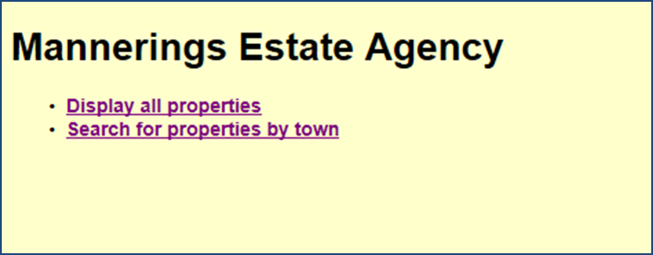

And page **display.php:**

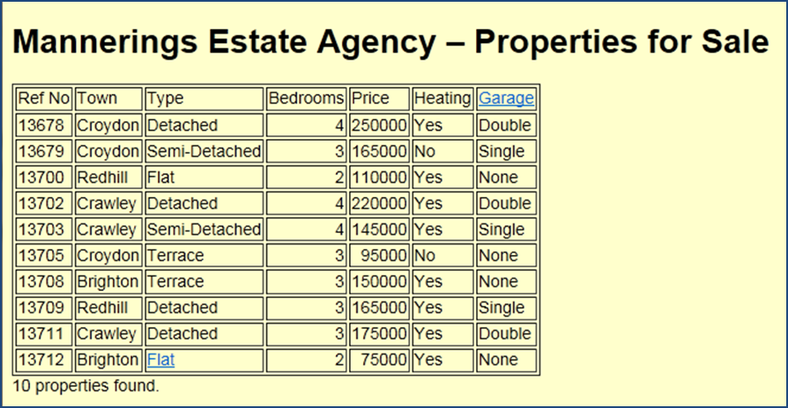

And page **search.php**

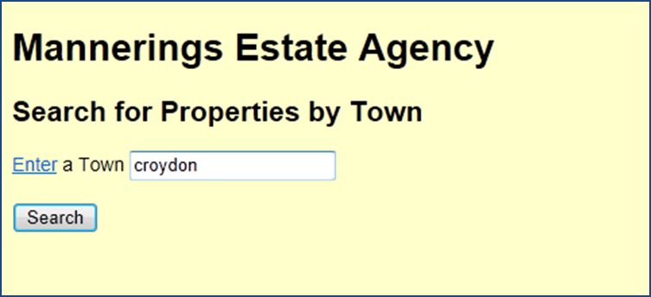

**DESCRIPTION OF PROJECT AND TASKS**

* + The “Display all properties” text link to page **display.php**.
  + The “Search for properties by town” text link to page **search.php**.
  + The display.php page write code to display details of all houses in table format and also to display the number of properties.
* The input box for the town name has id "txtTown".
* The "Search" button has an id of "query".
* On clicking the Search button the page should be reloaded to display the relevant list of properties. ONLY ONE PAGE IS REQUIRED.

**GENERAL TRANSCRIPT**

|  |  |  |  |
| --- | --- | --- | --- |
| **Exam content** | | **Maximum Marks** | **Achieved**  **Marks** |
| 1 | Programming with HTML/CSS | 30 |  |
| 2 | Programming with JavaScript | 30 |  |
| 3 | Use the MySQL | 10 |  |
| 4 | Programming with PHP | 30 |  |
| **Total Marks** | | **100** |  |

**TEST TIME**

|  |  |  |  |  |  |  |  |
| --- | --- | --- | --- | --- | --- | --- | --- |
| **Get to know the equipment** | | **Time Duration** | | **Break Time** | | | |
| Starting time |  | Starting time |  | Starting time |  | Starting time |  |
| Ending time |  | Ending time |  | Ending time |  | Ending time |  |

**TEACHERS’ SIGNATURE**

|  |  |  |  |  |
| --- | --- | --- | --- | --- |
| **1** | **2** | **3** | **4** | **5** |
|  |  |  |  |  |